WILLIAM HENRY CHAPMAN

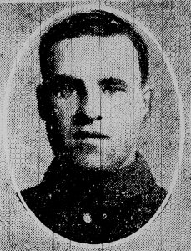
Image from 1916 Suffolk Chronicle and Mercury newspaper.
Born: 1894, Wilby, Suffolk.
Died: 1st August 1916; Died of Wounds – No. 21 Casualty Clearing Station.
Enlistment Location: Ipswich.
Rank: Private; Service Number: 24099
Regiment: Suffolk Regiment, 8th Battalion.
Medals Awarded: Victory & British War.

Grave Reference:
I.E.47.
La Neuville British Cemetery,
Corbie, Somme, France.
Relatives Notified & Address: Son of James Chapman, of 2, The Dales, Henley Road, Ipswich.
CENSUS
1901 Dale Hall Cottage, Henley Road, Whitton cum Thurleston, Suffolk.
William was 7 years old and living with his parents & siblings.
James Chapman, 37, a Stockman on a Farm, born Wilby, Suffolk.
Laura Chapman (nee Goddard), 33, born Southolt, Suffolk.
George Edward Chapman, 11, born Wilby, Suffolk.
James Chapman, 9, born Wilby.
Bessie Elizabeth Chapman, 5, born Wilby.
Sam Chapman, 1, born Framsden, Suffolk.

1911 The Dales, Henley Road, Ipswich.
William was 17 years old, a Milkman on a Farm. He was living with his parents & siblings.
James, 47, a Stockman on a Farm.
Laura, 42.
George, 21, a Milkman on a Farm.
James, 19, a Labourer on a Farm.
Sam, 11, School/part time Milkman.
Laura May Chapman, 9, born Ipswich.
Ida Lily Chapman, 7, born Ipswich.
Dora Kathleen Chapman, 1, born Ipswich.
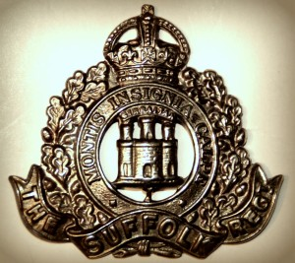

Suffolk Regiment, 8th Battalion

